My Parents and I Are Working from Home

My parents work has asked them to stay home to do their job so they can stay healthy. I must stay home from school to work to stay healthy too.
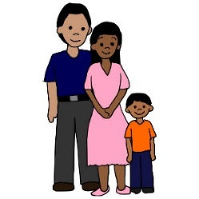

When I did my homework when I was in school, I sat at my desk in my room. During my work time now, I will use my same desk.

Dad is using the dining room table for his makeshift workspace at home.
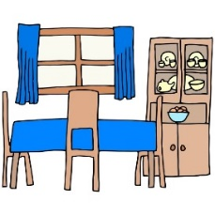

My mom moves around to different spots. Sometimes she sits next to me at my workspace and other times she sits next to dad at the dining room table.

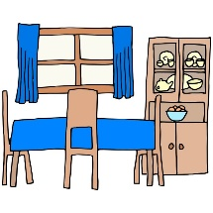

All of us will try to finish our work each day our teacher and boss tell us to do at home on Monday, Tuesday, Wednesday, Thursday, and Friday at home.

